Planetary motion simulation

by Tigran Tadevosyan

The values of masses, orbital speed, radius and distances from the Sun are represented in the table below.

| Planets | Orbital Speed (m/s) | Masses (${10}^{23}$ kg) | Radius (${10}^{3}$ m) | Distance from Sun (10^9 m) |
| --- | --- | --- | --- | --- |
| Sun | 0 | 19890000 | 695508 | 0 |
| Mercury | 47870 | 3.301 | 2439.7 | 58 |
| Venus | 35020 | 48.67 | 12104 | 108 |
| Earth | 29780 | 59.72 | 6371 | 150 |
| Mars | 24077 | 6.417 | 3390 | 228 |
| Jupiter | 13070 | 18990 | 69911 | 778 |
| Saturn | 9690 | 5685 | 58232 | 1400 |
| Uranus | 6810 | 868.2 | 25362 | 2900 |
| Neptune | 5430 | 1024 | 24622 | 4500 |

**Program**

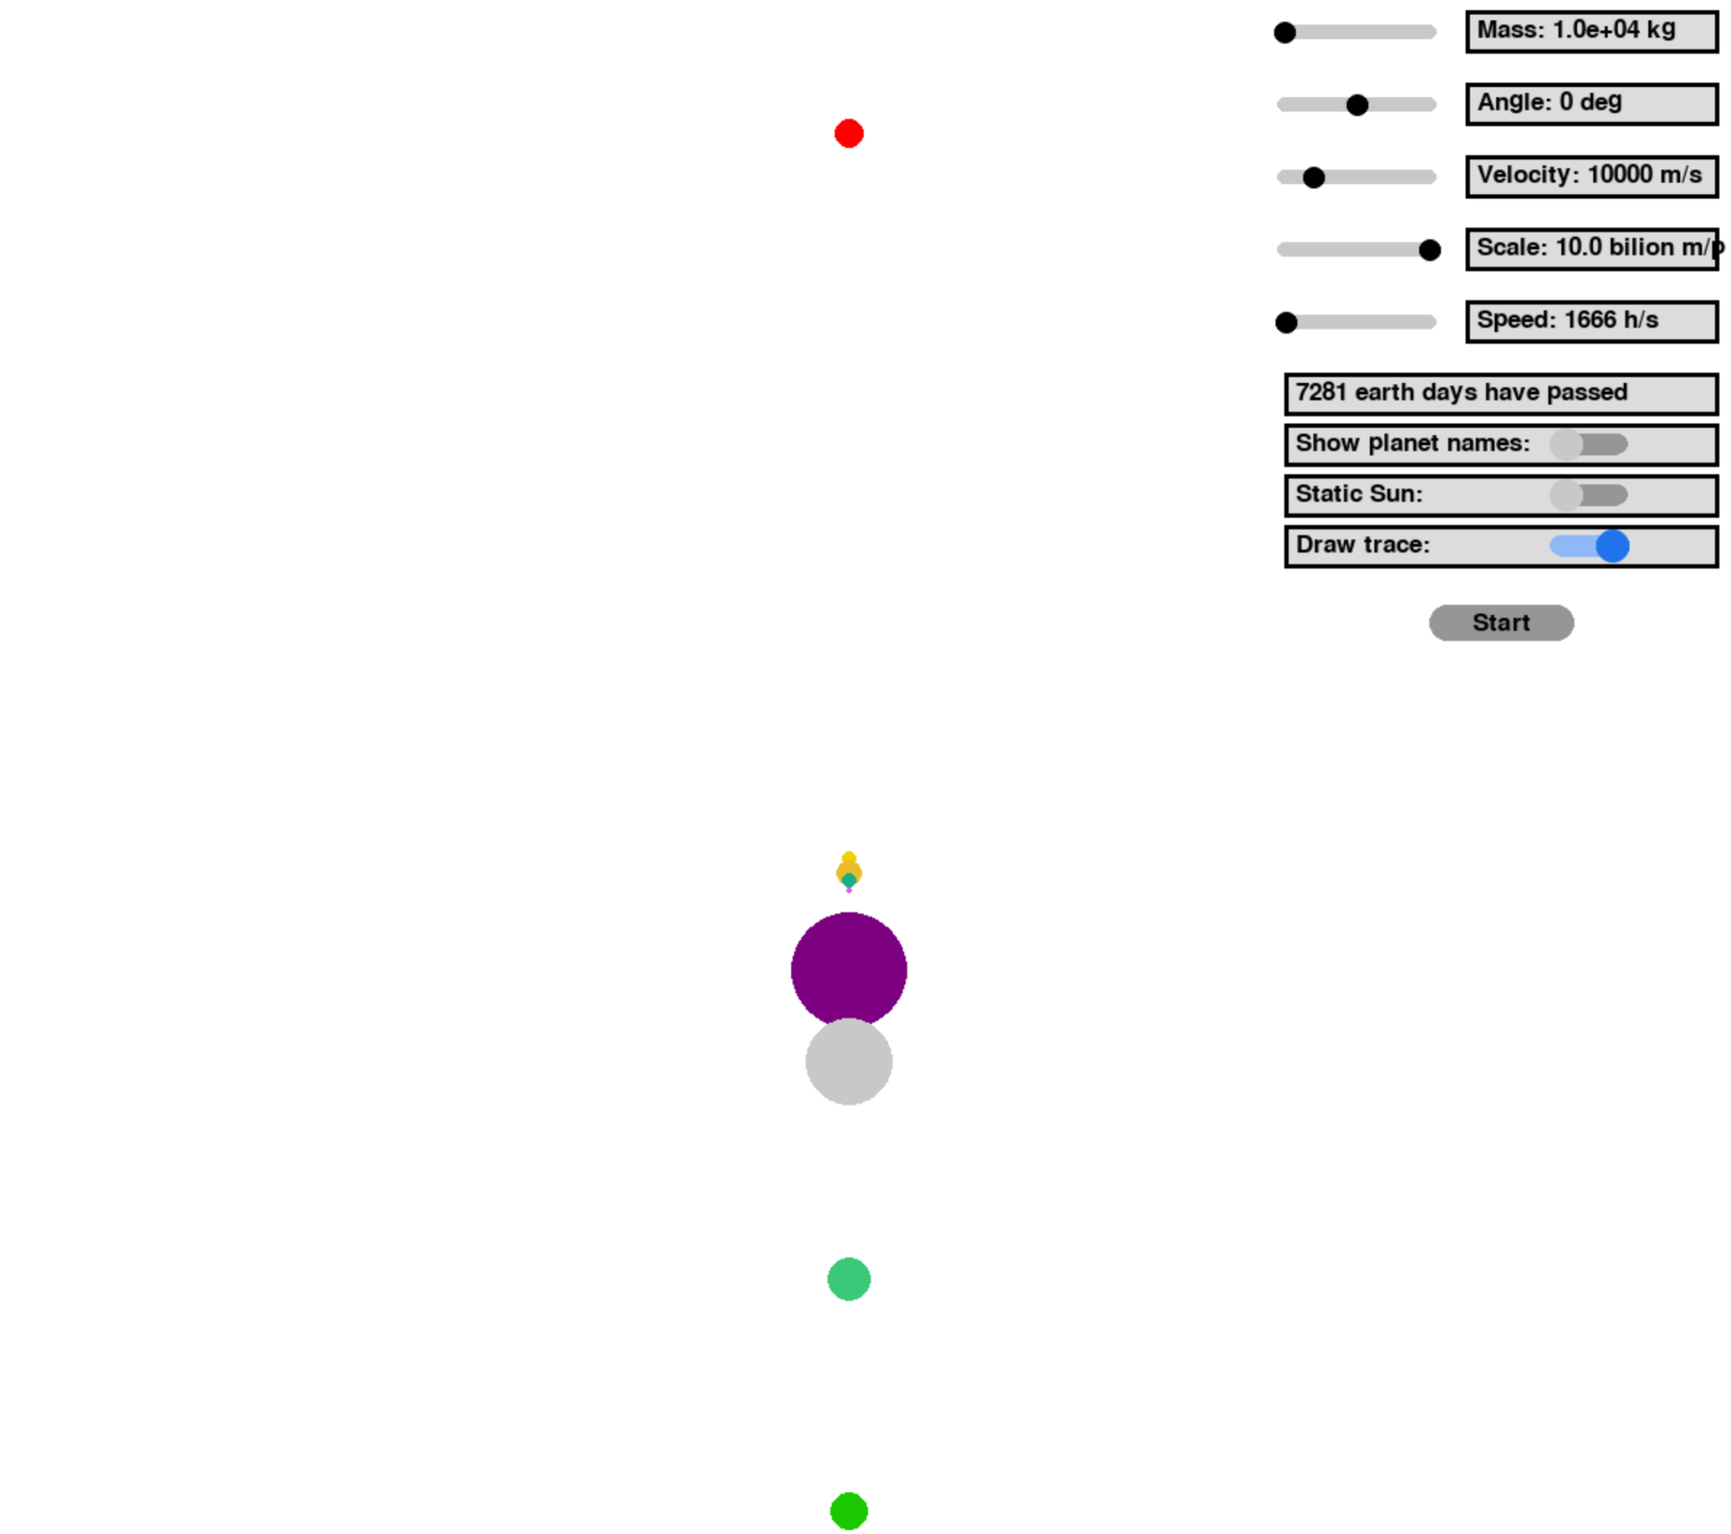

At the beginning of the simulation the planes are ordered in a straight line downwards from the Sun which is placed at the center of the screen. The distances between the planets are proportionally correct. Although the radius of planets are proportionally accurate to each other (except the Sun it is represented as a small yellow dot) they are not accurately related to the distances between planets as they would not be visible in that case. In the program the planets don’t have an elliptic shape and are represented as circles. Moreover, the shape of the orbits is not elliptic as in the real world, but is represented as circles. At the start of the simulation planets have velocies to the right, so they are doing counter-clockwise rotation. The asteroid is placed 5 $×{10}^{12}m$ above the Sun. The asteroid in the program is shown as Red circle.

All the measurements in the program are used in meters and seconds. The position from the asteroid is released at selected angles from -90° degrees to 90° related to the asteroid-sun line. The mass of the asteroid is selected from 1.0e + 3 kg up to 1.0e + 09kg. Asteroid itself has initial velocity which also has bounds from 0m/s to 50000 m/s. Obviously the simulation is not running in real time. The speed of simulation can be changed in the range of 277 h/s (hours per second) to 111111 h/s, where for example for the value of 500 h/s the simulation’s 1 second would constitute 500 hours in real time. The time passed since the start of simulation is displayed in earth days. When the asteroid approaches one of the planets even the Sun can change its direction because of its gravitational attraction’s effect on our asteroid(if it has sufficient mass) on the Sun. Moreover, the user can toggle between static or moving Sun.

**Distance**

To find the direction of gravitational force between two celestial bodies we need to find the vector from one of them to the other one. For example if we want to find the force of the Sun (positional vector - $\underline{OB}$) on Earth (positional vector - $\underline{OA}$) we must find the vector $\underline{AB}$ (from Earth to Sun) because it is the direction the Sun’s gravitational force acts on Earth. The normalized vector of $\underline{AB}$ would show the direction of the force in interest. So $\underline{AB}=\underline{OB}-\underline{OA}≡\underline{D}$, where $\frac{\underline{D}}{\left|\underline{D}\right|}≡\underline{n}$ is the norm of our vector, the $\underline{D}$ represents the positional difference between them.



**Acceleration**

For acceleration is used Newton’s Second law and gravitational force equation, where we get from Newton’s law $\underline{F}=m_{A}\underline{a}$ and |. As we are not just interested in the absolute value of the gravitational force we must multiply it’s absolute value with the vector $\underline{n}$ to find the force vector.

$\underline{F}=\frac{Gm_{A}m_{B}}{{\left|\underline{D}\right|}^{2}}⋅\underline{n}$

$m_{A}\underline{a}=$ $\frac{Gm_{A}m_{B}}{{\left|\underline{D}\right|}^{2}}⋅\underline{n}$

$\underline{a}=\underline{n}⋅\frac{Gm_{B}}{{\left|\underline{D}\right|}^{2}}$

**Velocity**

For velocity is used the time and acceleration, which we get $\underline{v}=dt⋅\underline{a}$

**Position**

We set the framerate of our simulation to be 60 fps, so the picture would be update once every 16.6666666667 seconds (if the computational power is sufficient). On every update we calculate the new position with $\underline{p}=dt⋅\underline{v}$. Then from the superposition of forces we add all the acceleration vectors we get from gravitational forces on the object of interest and we get the acceleration of that object. We calculate the change in velocity from the aforementioned formula, which we would use to calculate the position on the next update cycle. After a few tests on the simulation we found out that the accuracy is not sufficient as Mercury would leave its orbit after a certain time. To fix this issue we have divided every interval into 500 subintervals and on every update cycle we calculate the aforementioned values in 500 subintervals.

The last part is the trace behind the asteroid. This is important because it helps to visualize the trajectory of the asteroid as it passes through the system. The trace is just lines connecting the last 100 positional points (longer than 1 pixel) the asteroid has passed. If we draw the trace in this manner we do not only get the visual information about the trajectory, but about velocity too as for higher velocity the trace of the last 100 points would be longer.

**Video Representation**



